MC Animation

THANK-YOU for your purchase!

User Guide
Thanks very much for purchasing your McAnimation animation pack.
Let's get started!

1.
First, let's import your new animations into Unity.
If you've downloaded a .unitypackage from the Asset Store within Unity, then it should automatically prompt you to import it. Alternatively if you have the .unitypackage on its lonesome then, while inside Unity, import it by clicking: Assets > Import Package > Custom Package as indicated in the image below.
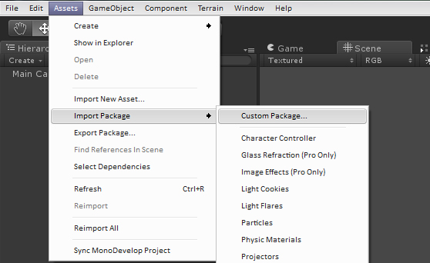

Then locate the directory where the .unitypackage is located, then - either double-click on the file or click the file, then click 'Open' as indicated in the image below.
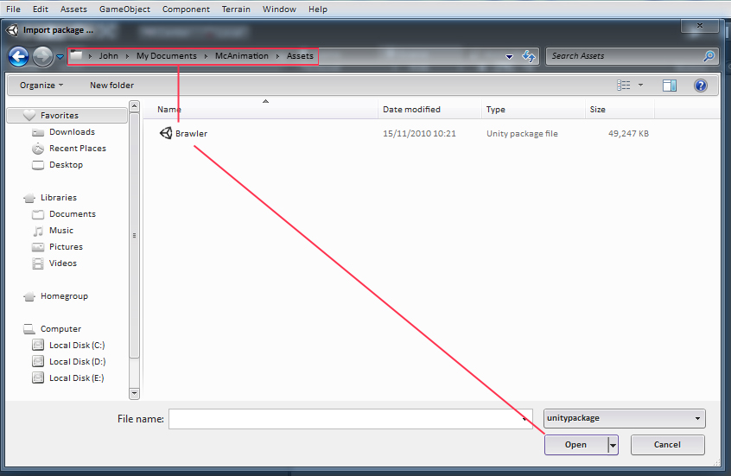
The 'Import Package' dialog box should pop-up. You can select the assets from the package that you'd like to import by clicking the checkboxes on the left-hand side (you might not want to import the .ma versions of the animations for instance). Once the items you want are ticked, click the 'Import' button in the bottom-right corner.
[Picture on the next page]

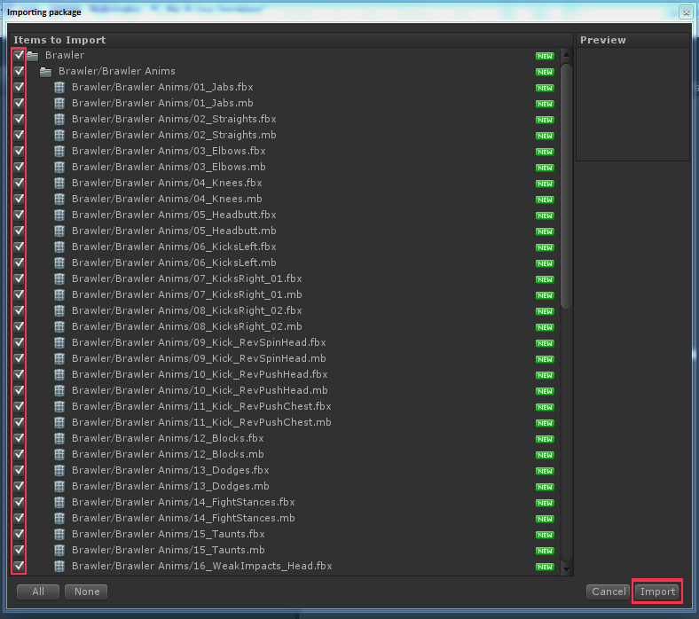
Once 'Import' is clicked, the assets will be loaded into Unity into your 'Assets' folder, more specifically into a folder named after the respective animation pack e.g. 'Brawler'.
Inside this new folder will be 2 or 3 folders containing 'Animations', 'Meshes' and perhaps 'Bonus Animations'.
Alternatively, if you have imported these assets on another computer or project and wish to move them into another copy of Unity or project, then just copy the main folder (e.g. 'Brawler') into the new Unity project's respective 'Assets' folder.

2.
Working with your new animations.
Locate the 'anims' folder in your Unity 'Project' window and click on it to reveal the animation contents within. Clicking on a particular animation will reveal its properties in Unity's 'Inspector' window. By clicking on the 'Animations' button at the top of the inspector and then clicking on the take (be default 'Take 001') there will be a message in the preview window that reads: 'No model is available for preview. Please drag a model into the Preview Window'.
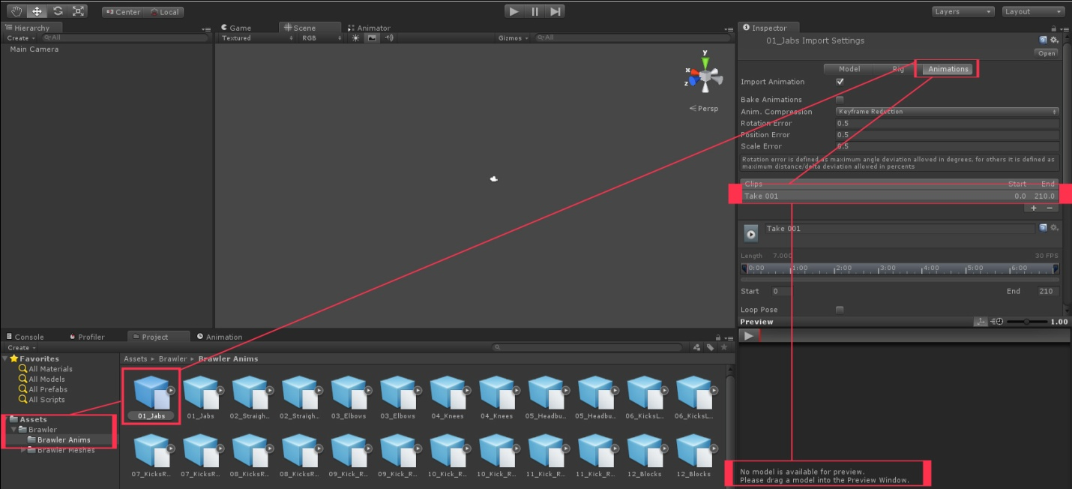
To preview the animation, first click on the 'Rig' button (on the left of the 'Animation' button) then change the 'Animation Type' from 'Generic' to 'Humanoid', uncheck 'Keep Additional Bones', then click 'Apply'.
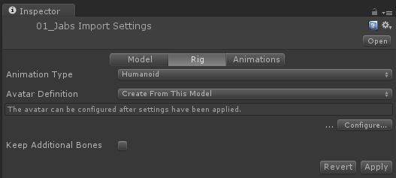
Now return to the 'project window', select the folder named 'Brawler Meshes' [This will be different depending on what animation pack you're working with e.g. replace the word 'Brawler' with 'Sci-Fi' if you're using the Sci-Fi pack etc.] inside the 'Brawler' folder. Now select a model. The model selected for this guide is: Brawler_LOW_fbx.fbx
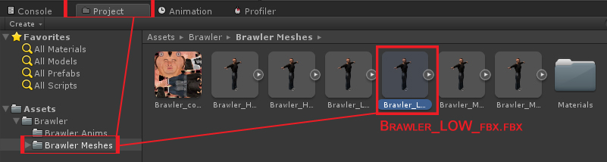

Navigate over to the 'Inspector' window and click on the 'Rig' button. Change the Animation Type from 'Generic' to 'Humanoid' and make sure the Avatar Definition is set to 'Create From This Model'. Ensure 'Keep Additional Bones' is unchecked and then click the 'Apply' button.
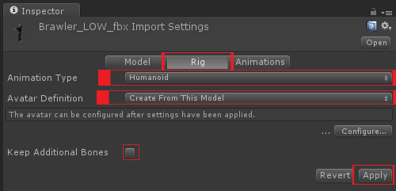

Now open this 'Anims' folder again, select the animation we were working with previously. Click the 'Animations' button, select 'Take 001' (by default).

Now in the preview window there will most likely be the Unity default 'dude' character that you can use to preview the animation. However, Navigate back to the 'Meshes' folder and then click & drag the model 'Brawler_LOW_fbx.fbx' into the preview window. Voila! Now you can preview the animation on that particular model.
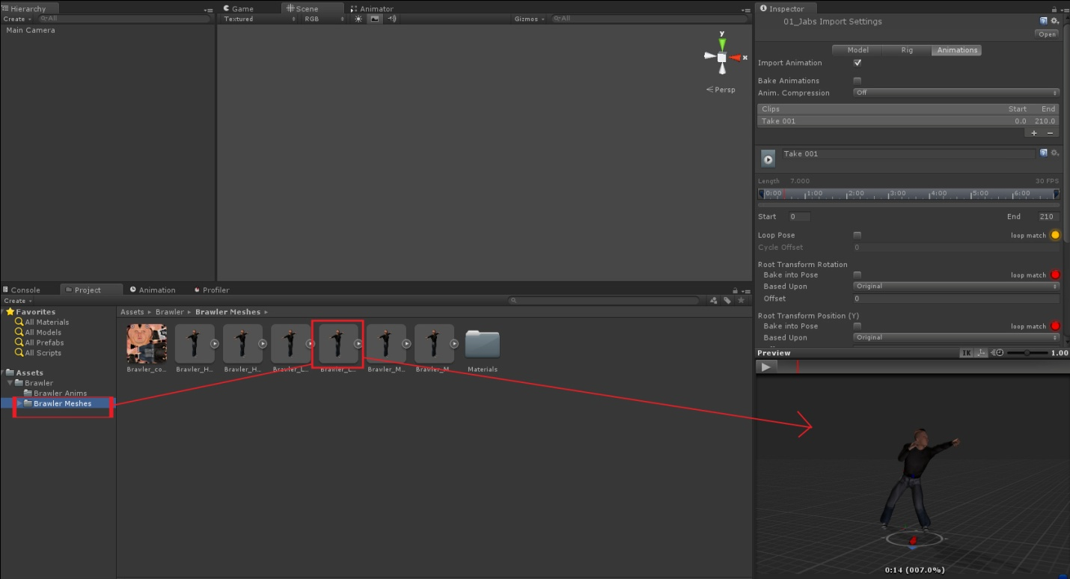

3.
Working with Animations.

The animation files provided (e.g. 01_Jabs) often contain more than 1 animation. Inside the included folder 'Animation Times' there is a file in different formats with the frame times of the included animations. This is a helpful guide to cropping and extracting the particular animations (Takes) in the Inspector that you want to use.
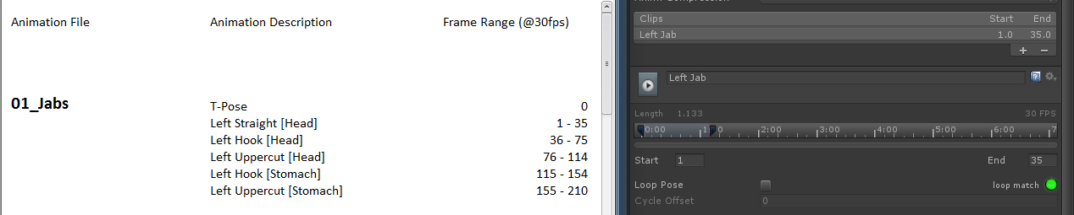

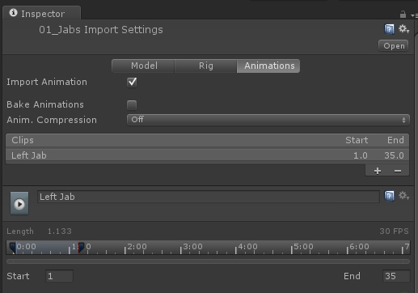

Working with Animations
Working with animations in Unity is a comprehensive topic that has been well covered in the official video tutorials by experts behind Unity.
They've covered the topic much more thoroughly and intelligibly than I possibly could, so here's the valuable free resources that cover the process:
A comprehensive tutorial by Unity, this is as good as it gets.
Become an animation master in Unity in under an hour!
http://www.youtube.com/watch?v=Xx21y9eJq1U

Documentation link for Unity's animation system. All you need to know!
http://docs.unity3d.com/Documentation/Manual/MecanimAnimationSystem.html

Incorporate Animations into a Project

http://unity3d.com/learn/tutorials/projects/stealth

Best regards,
John @ McAnimation

